STANDARD FORMAT OF “LEHENGA DESCRIPTION”


For Online Selling Products
Design Name: AANGAN-A
Product Colours NO.: A1
. 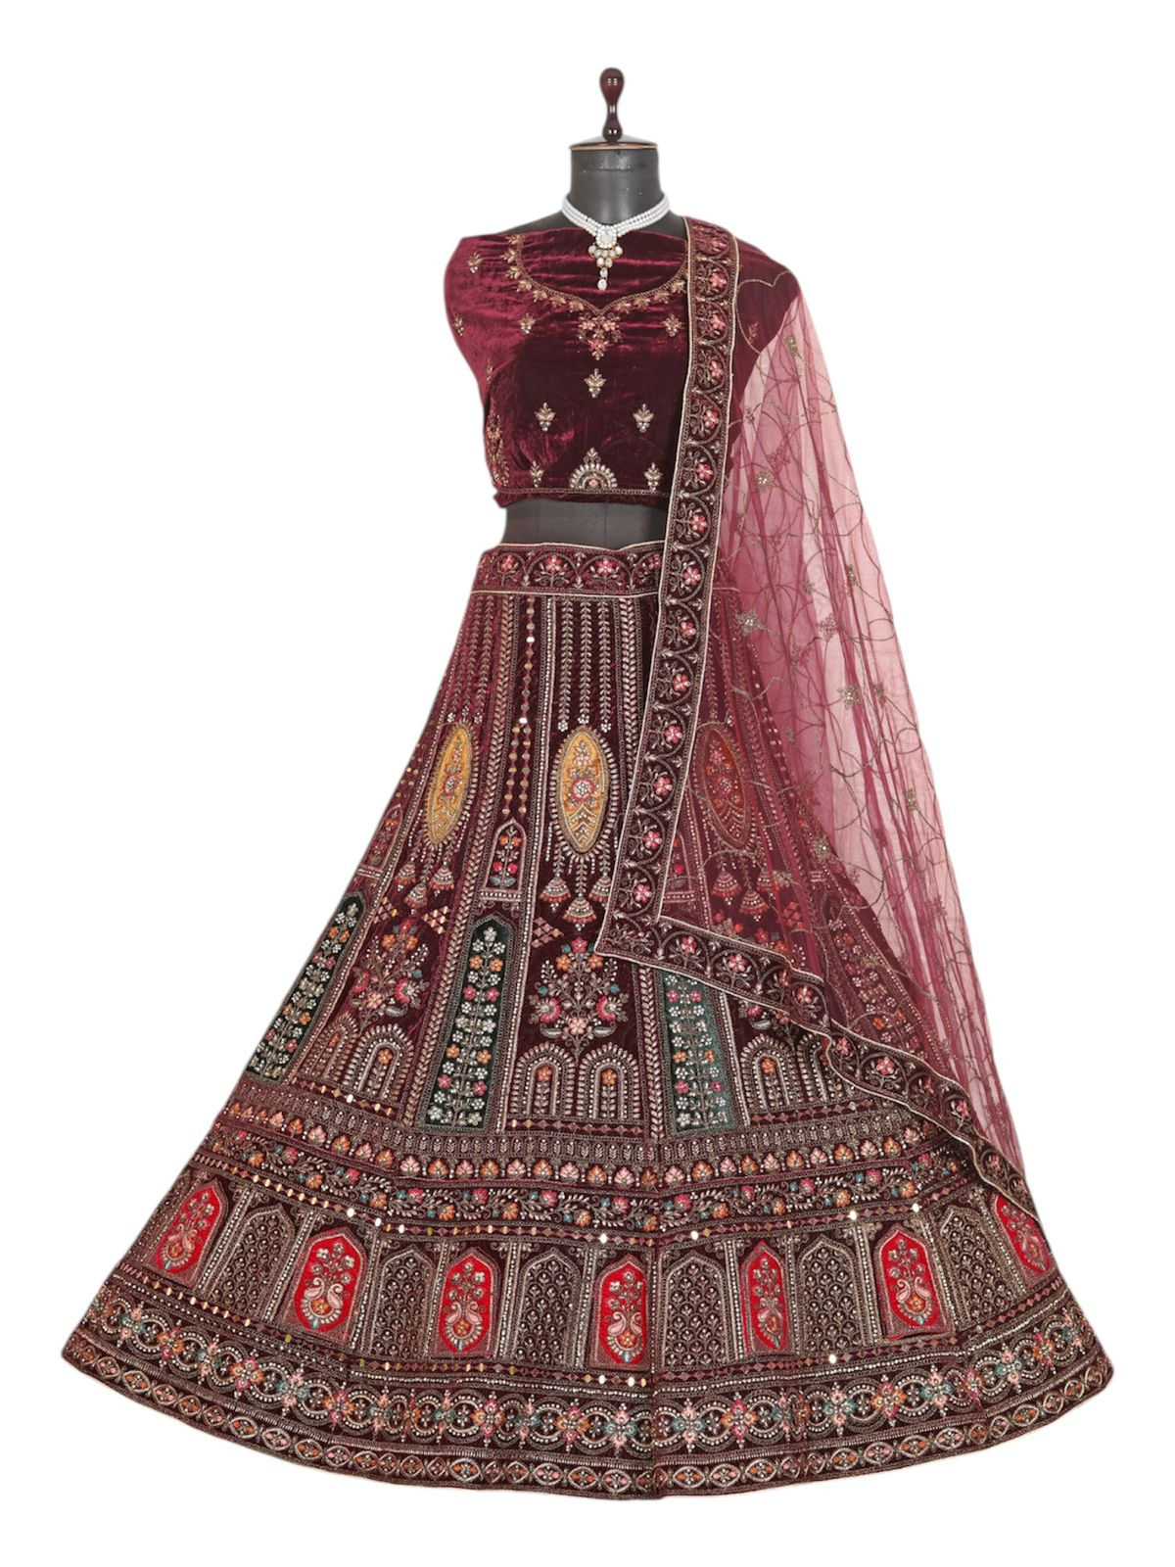
Particulars | Details
Lehenga Fabric | Velvet
Blouse Fabric | Velvet
Dupatta Fabric | Net
Work Type | Jari, Jarkan – embroidery Work
Colour | Maroon
Pattern | Bridal Designer Lehenga
Stitching Type | Semi-Stitched (Can be customized up to 44")
Occasion | Wedding, Reception, Engagement & Festive Wear
Fit Type | Regular Fit
Care Instructions | Dry Clean Only
Package Contents | 1 Lehenga, 1 Blouse Piece, 1 Dupatta

KEY HIGHLIGHTS
- Premium-quality Velvet Fabric for a rich and royal look
- Heavy Jari & Jarkan embroidery for a luxurious bridal appeal
- Comes with matching velvet blouse and elegant net dupatta
- Ideal for wedding, reception, and grand festive events
- Semi-stitched lehenga allows easy customization
- Soft velvet ensures comfort and perfect drape
- Traditional craftsmanship blended with modern bridal styling

